**Time Complexity of Sorting Algorithms**

**Data Structures and Algorithms**



**Submitted To:**

Miss Drakshan Bokhat

**Submitted By:**

Rabbia Batool (22-SE-04)

Laiba Mukhtar (22-SE-16)

**University of Engineering and Technology Lahore (New Campus)**

**Merge Sort**

|  |  |  |
| --- | --- | --- |
| Input Size | Machine 1 | Machine 2 |
| 1000 | **0.046000 secs** | **0.001secs** |
| 2000 | **0.186000 secs** | **0.001secs** |
| 3000 | **0.43000 secs** | **0.001secs** |
| 4000 | **1.257000 secs** | **0.003secs** |
| 5000 | **1.598000 secs** | **0.003secs** |
| 10000 | **4.847000 secs** | **0.007secs** |
| 20000 | **14.051000 secs** | **0.008secs** |
| 40000 | **46.964000 secs** | **0.015secs** |
| 80000 | **--** | **0.07secs** |
| 160000 | **--** | **0.016secs** |
| 250000 | **--** | **0.258secs** |
| 500000 | **--** | **--** |

**Quick Sort**

|  |  |  |
| --- | --- | --- |
| Input Size | Machine 1 | Machine 2 |
| 1000 | 0.001000 secs | 0.00secs |
| 2000 | 0.001000 secs | 0.00secs |
| 3000 | 0.000000 secs | 0.001secs |
| 4000 | 0.001000 secs | 0.001secs |
| 5000 | 0.001000 secs | 0.001secs |
| 10000 | 0.002000 secs | 0.003secs |
| 20000 | 0.003000 secs | 0.0013secs |
| 40000 | 0.009000 secs | 0.043secs |
| 80000 | 0.015000 secs | 0.159secs |
| 160000 | 0.032000 secs | **--** |
| 250000 | 0.058000 secs | **--** |
| 500000 | **--** | **--** |

**Bubble Sort**

|  |  |  |
| --- | --- | --- |
| Input Size | Machine 1 | Machine 2 |
| 1000 | 0.005000 secs | 0.003secs |
| 2000 | 0.019000 secs | 0.008secs |
| 3000 | 0.039000 secs | 0.012secs |
| 4000 | 0.075000 secs | 0.031secs |
| 5000 | 0.127000 secs | 0.035secs |
| 10000 | 0.654000 secs | 0.29secs |
| 20000 | 3.280000 secs | 1.039secs |
| 40000 | 9.050000 secs | 3.806secs |
| 80000 | 33.182000 secs | 13.379secs |
| 160000 | 2 minutes and 6.491000 secs | 52.615secs |
| 250000 | 3 minutes and 10.484000 secs | 139.896secs |
| 500000 | 21 minutes and 22.585000 secs | **--** |

**Selection Sort**

|  |  |  |
| --- | --- | --- |
| Input Size | Machine 1 | Machine 2 |
| 1000 | 0.002000secs | 0.003secs |
| 2000 | 0.006000secs | 0.012secs |
| 3000 | 0.018000secs | 0.042secs |
| 4000 | 0.033000secs | 0.021secs |
| 5000 | 0.043000secs | 0.038secs |
| 10000 | 0.182000secs | 0.143secs |
| 20000 | 0.841000secs | 0.757secs |
| 40000 | 4.162000secs | 2.748secs |
| 80000 | 12.467000secs | 8.329secs |
| 160000 | 42.046000secs | 30.675secs |
| 250000 | 1 minute and 22.784000 secs | 74.848secs |
| 500000 | 3 minutes and 16.579000secs | **--** |

**Insertion Sort**

|  |  |  |
| --- | --- | --- |
| Input Size | Machine 1 | Machine 2 |
| 1000 | 0.001000secs | 0.002secs |
| 2000 | 0.005000secs | 0.002secs |
| 3000 | 0.011000secs | 0.006secs |
| 4000 | 0.019000secs | 0.013secs |
| 5000 | 0.024000secs | 0.011secs |
| 10000 | 0.135000secs | 0.057secs |
| 20000 | 0.487000secs | 0.308secs |
| 40000 | 2.482000secs | 1.067secs |
| 80000 | 8.204000secs | 3.153secs |
| 160000 | 26.285000secs | 10.689secs |
| 250000 | 1 minute and 1.688000 secs | 25.087secs |
| 500000 | 4 minutes and 12.205000 secs | **--** |

**Complexity Graphs**

**Selection Sort**

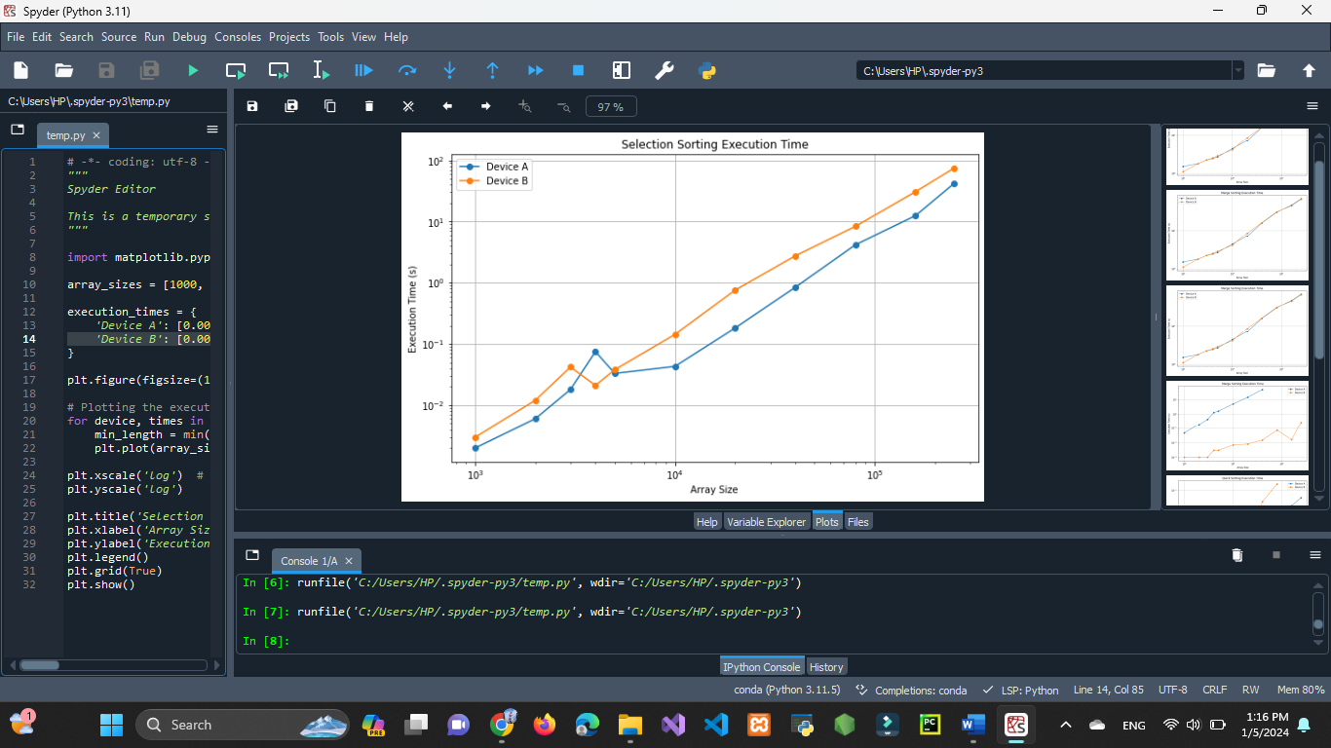

**Insertion Sort**

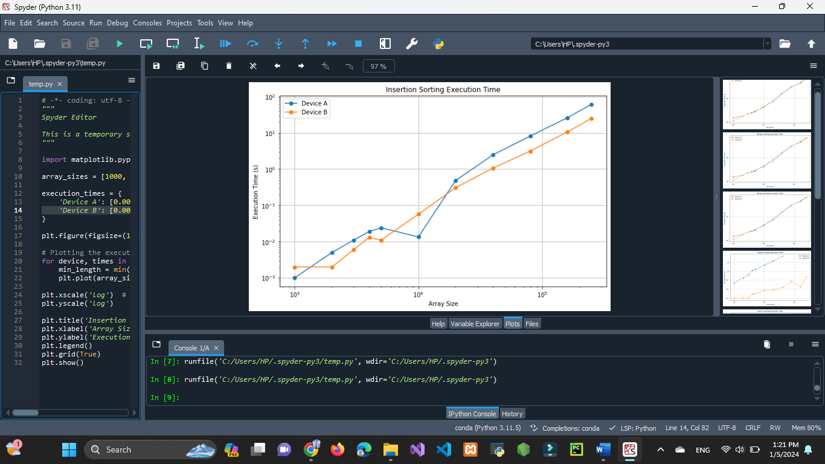

**Quick Sort**

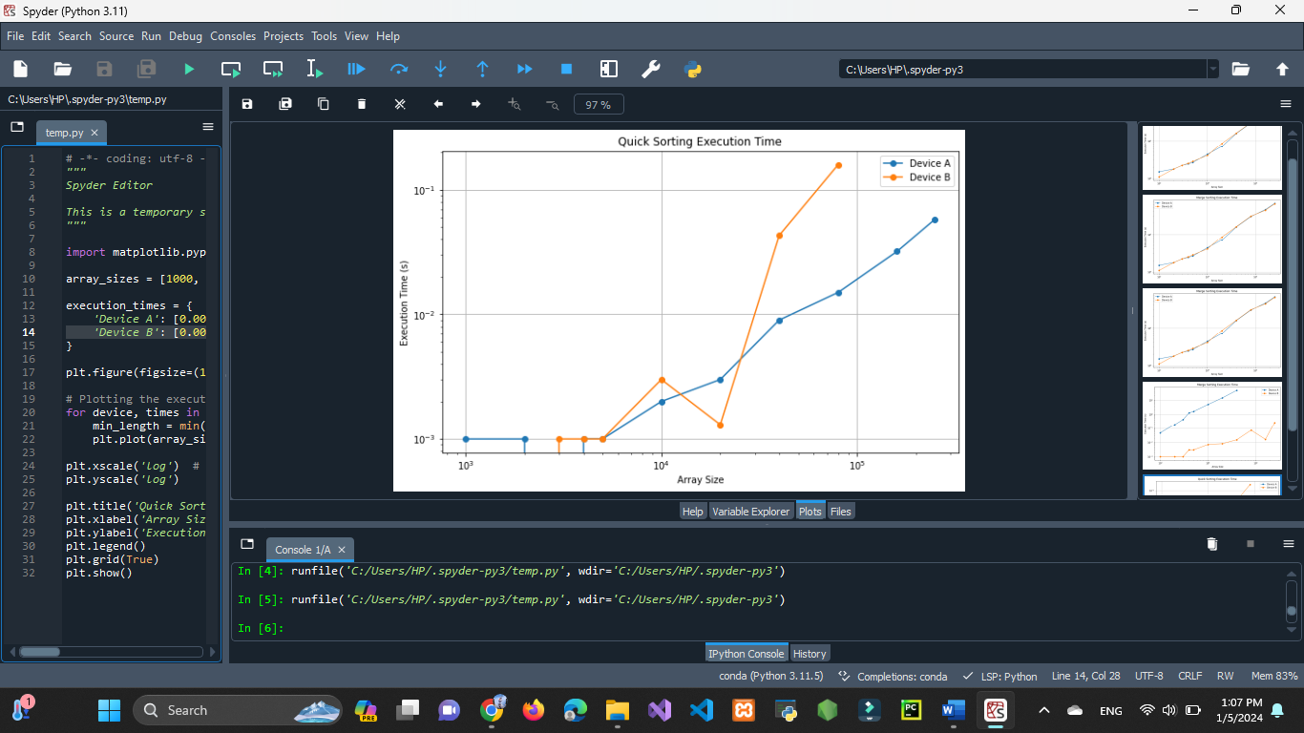

**Bubble Sort**

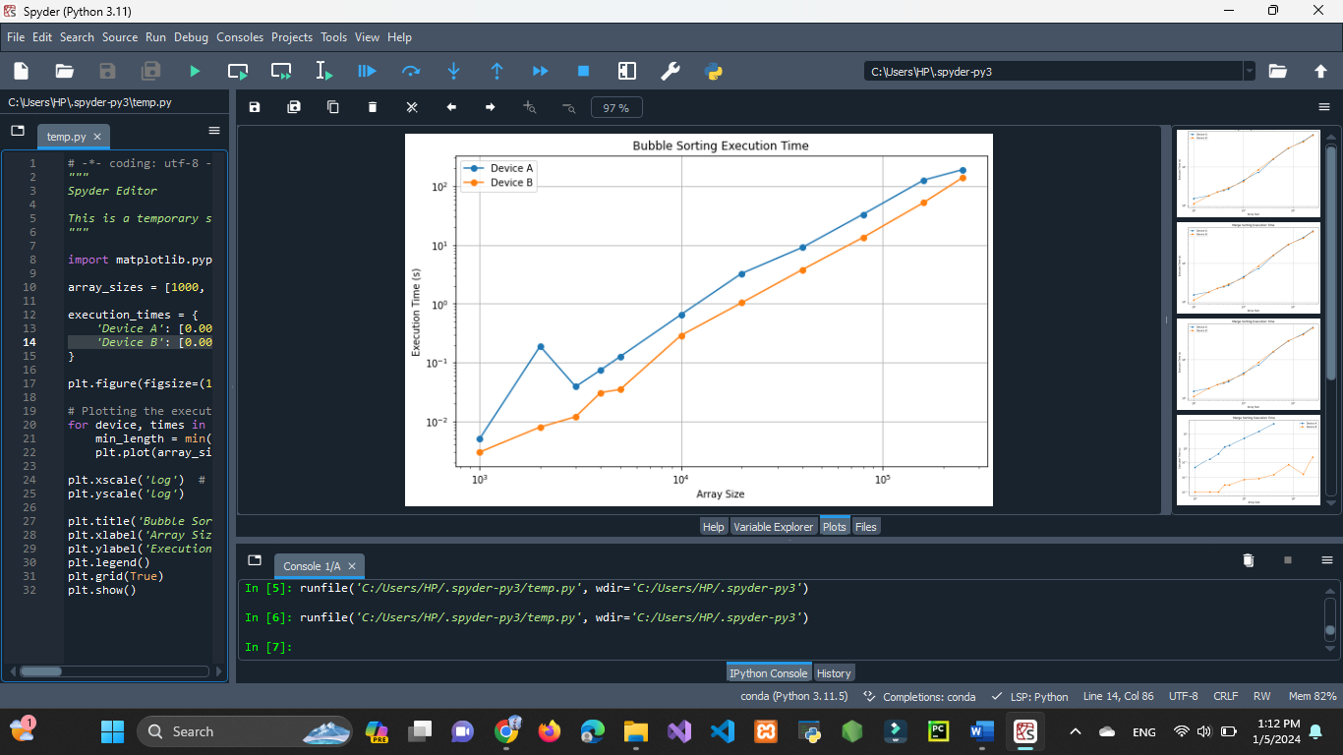

**Merge Sort**

